**Code : Triangle of Numbers**

**Send Feedback**

Print the following pattern for the given number of rows.

**Pattern for N = 4**

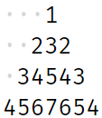

The dots represent spaces.

**Input format :**

Integer N (Total no. of rows)

**Output format :**

Pattern in N lines

**Constraints :**

0 <= N <= 50

**Sample Input 1:**

5

**Sample Output 1:**

1

232

34543

4567654

567898765

**Sample Input 2:**

4

**Sample Output 2:**

1

232

34543

4567654